Convolution Networks
BA 64061 Advanced Machine Learning
Christian Osadebe

1. Purpose
This assignment applies convolutional networks (convnets) to image data, using the Cats & Dogs classification example. It examines one question: how does the size of the training sample affect the choice between training a convnet from scratch and using a pretrained network? Six models were trained — three from scratch and three using a pretrained network — at training sample sizes of 1,000, 1,500 and 2,000 images. The validation sample (500 images) and test sample (500 images) were held fixed for every model, so that the effect of training size and of the choice of network could be compared directly.

2. Data
The data is the small Cats & Dogs dataset provided for this module, drawn from the Kaggle Dogs vs. Cats competition. The training pool contains 2,000 images (1,000 cats, 1,000 dogs). Following the assignment instructions, the 1,000 training sample was drawn by random sampling (500 per class); the 1,500 and 2,000 samples extend the same lists (750 and 1,000 per class), so the samples are nested and training size is the only factor that changes between runs. All images were resized to 150 × 150 with three color channels and rescaled to values between 0 and 1.

3. Method — training from scratch
The from-scratch model is a convnet of convolution and max-pooling layers with 32, 64, 128, and 128 filters, ending in a 7 × 7 × 128 feature map, followed by flattening, a dropout layer (0.5), a dense layer of 512 units with ReLU activation, and a single sigmoid output unit. It was compiled with binary cross-entropy loss and the RMSprop optimizer and trained for 30 epochs with a batch size of 32. Two techniques were used against overfitting: data augmentation and dropout. The same model and settings were used at all three training sizes.
Training = 1,000: best validation accuracy 0.680, test accuracy 0.678.
Training = 1,500: best validation accuracy 0.712, test accuracy 0.686.
Training = 2,000: best validation accuracy 0.730, test accuracy 0.696.
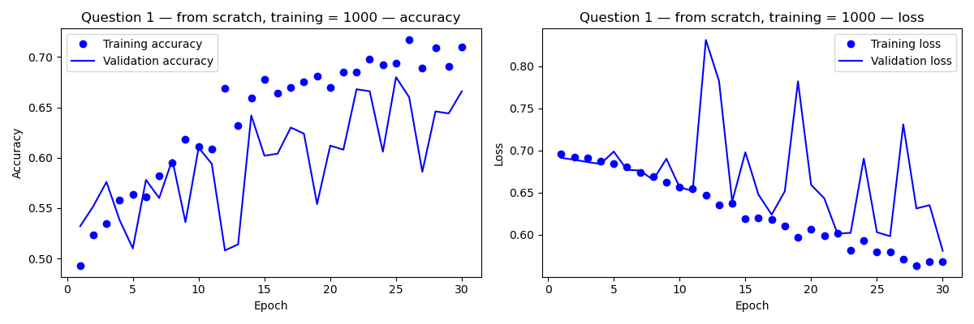
The accuracy and loss curves showed the expected overfitting pattern: training accuracy rose steadily across the 30 epochs, and training loss fell, while validation accuracy improved more slowly, fluctuated from epoch to epoch, and validation loss spiked in some epochs. The pattern was present at all three training sizes — augmentation and dropout reduced overfitting but did not remove it.
4. Method — pretrained network
The pretrained approach uses VGG16, a convnet pretrained on ImageNet, with its classification top removed and its convolutional base frozen. Each image was passed once through the base to extract features (a 4 × 4 × 512 feature map), and a small classifier — a dense layer of 256 ReLU units, dropout (0.5), and a sigmoid output — was trained on those features with RMSprop at a low learning rate for 30 epochs. The training sizes matched the from-scratch runs: 1,000, 1,500 and 2,000, with the same fixed validation and test sets.
Training = 1,000: best validation accuracy 0.898, test accuracy 0.884.
Training = 1,500: best validation accuracy 0.906, test accuracy 0.884.
Training = 2,000: best validation accuracy 0.912, test accuracy 0.892.

5. Results
Approach | Training size | Best validation accuracy | Test accuracy
From scratch | 1,000 | 0.680 | 0.678
From scratch | 1,500 | 0.712 | 0.686
From scratch | 2,000 | 0.730 | 0.696
Pretrained (VGG16) | 1,000 | 0.898 | 0.884
Pretrained (VGG16) | 1,500 | 0.906 | 0.884
Pretrained (VGG16) | 2,000 | 0.912 | 0.892
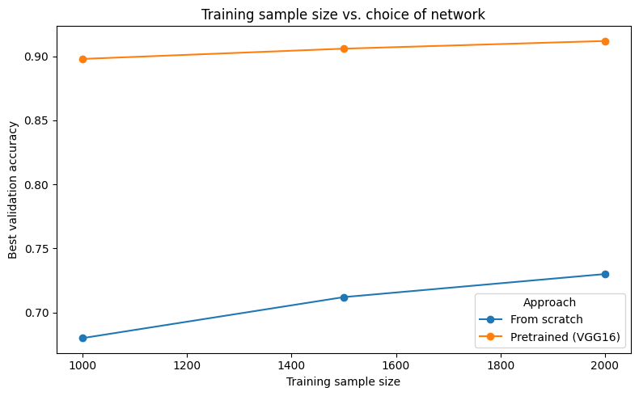

Summary graph — best validation accuracy by training sample size

6. Discussion — the relationship between training sample size and choice of network
A convnet trained from scratch must learn its visual features from the training images themselves. With only 1,000 training images, it overfits quickly, and its validation accuracy improves substantially as the training sample grows to 2,000 — in this experiment, from 68.0% at 1,000 to 73.0% at 2,000. A pretrained network begins with features already learned from a very large dataset, so it reaches 89.8% with only 1,000 training images and gains much less as the sample grows, reaching 91.2% at 2,000. The ideal training size found for the from-scratch network was 2,000, the largest tested — its validation accuracy was still rising at that point — while the pretrained network was already close to its best at 1,000 and gained only slightly from the extra images.

7. Conclusion
On this evidence, the choice of network depends on how much training data is available. With a small training sample, the pretrained network is clearly the better choice, because it borrows features learned elsewhere instead of having to learn them from too few images. As the training sample grows, the from-scratch network closes part of the gap, but it did not catch the pretrained network at 2,000 images (73.0% against 91.2% best validation accuracy). For a problem of this size, the recommendation is the pretrained network (VGG16) — it was the better choice at every training size tested, and its advantage was largest when training data was smallest.

